<http://www.deviantart.com/art/Epic-Keys-210348788>



http://www.deviantart.com/art/One-dollar-koi-new-ver-side-57234934



http://www.deviantart.com/art/Wheatley-Puppet-252080280



<http://www.deviantart.com/art/Origami-Winged-Koi-172447861>



<http://www.deviantart.com/art/egyptian-collar-270073803>



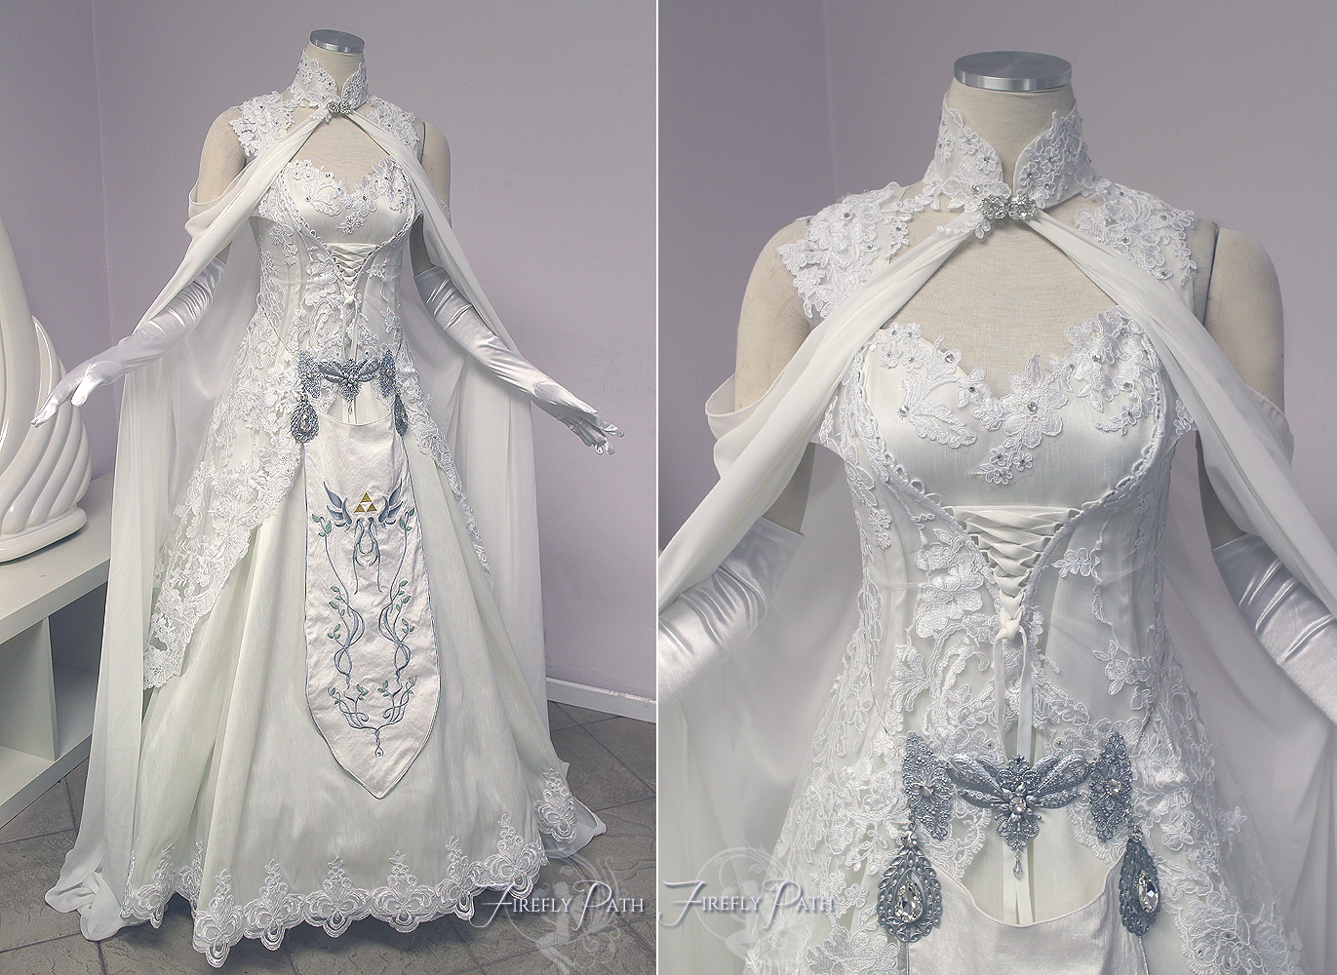

<http://firefly-path.deviantart.com/art/Princess-Zelda-Wedding-Dress-581860396>

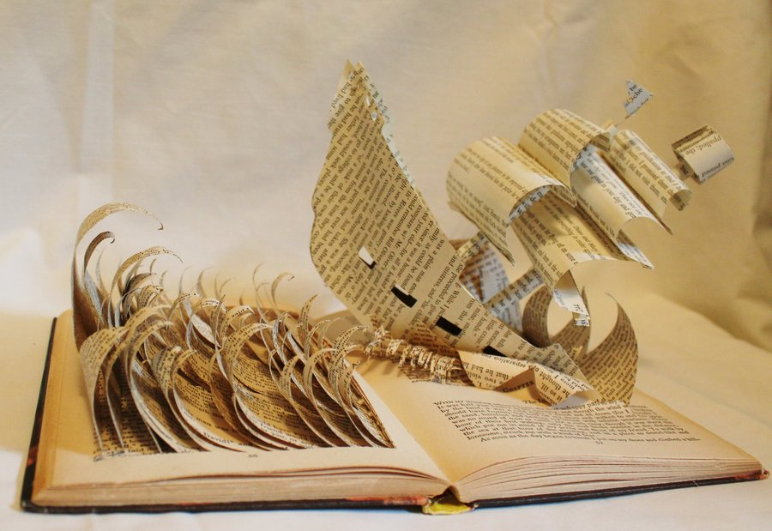

<http://wetcanvas.deviantart.com/art/Pirate-Ship-Book-Alteration-302279920>

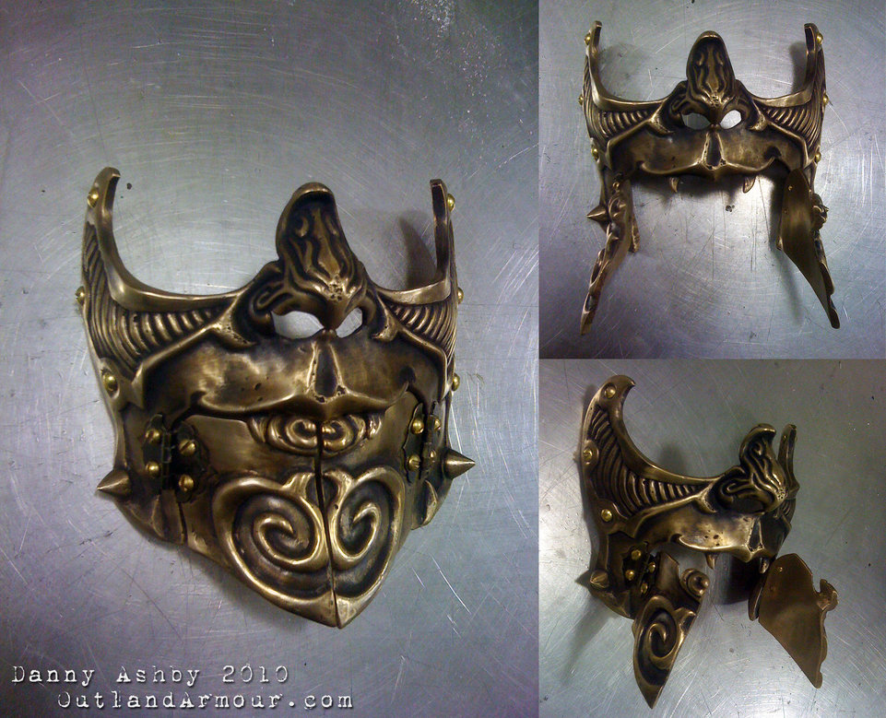

<http://vynettedantes.deviantart.com/art/Steampunk-Carnival-Battle-Mask-157529272>

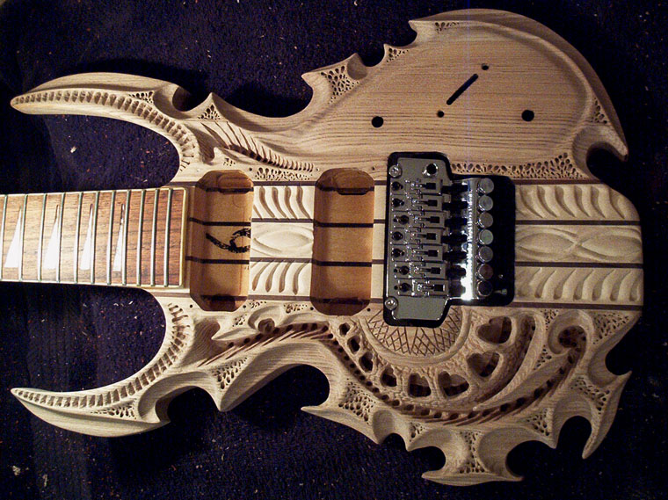

<http://vankuilenburg.deviantart.com/art/more21-95725904>

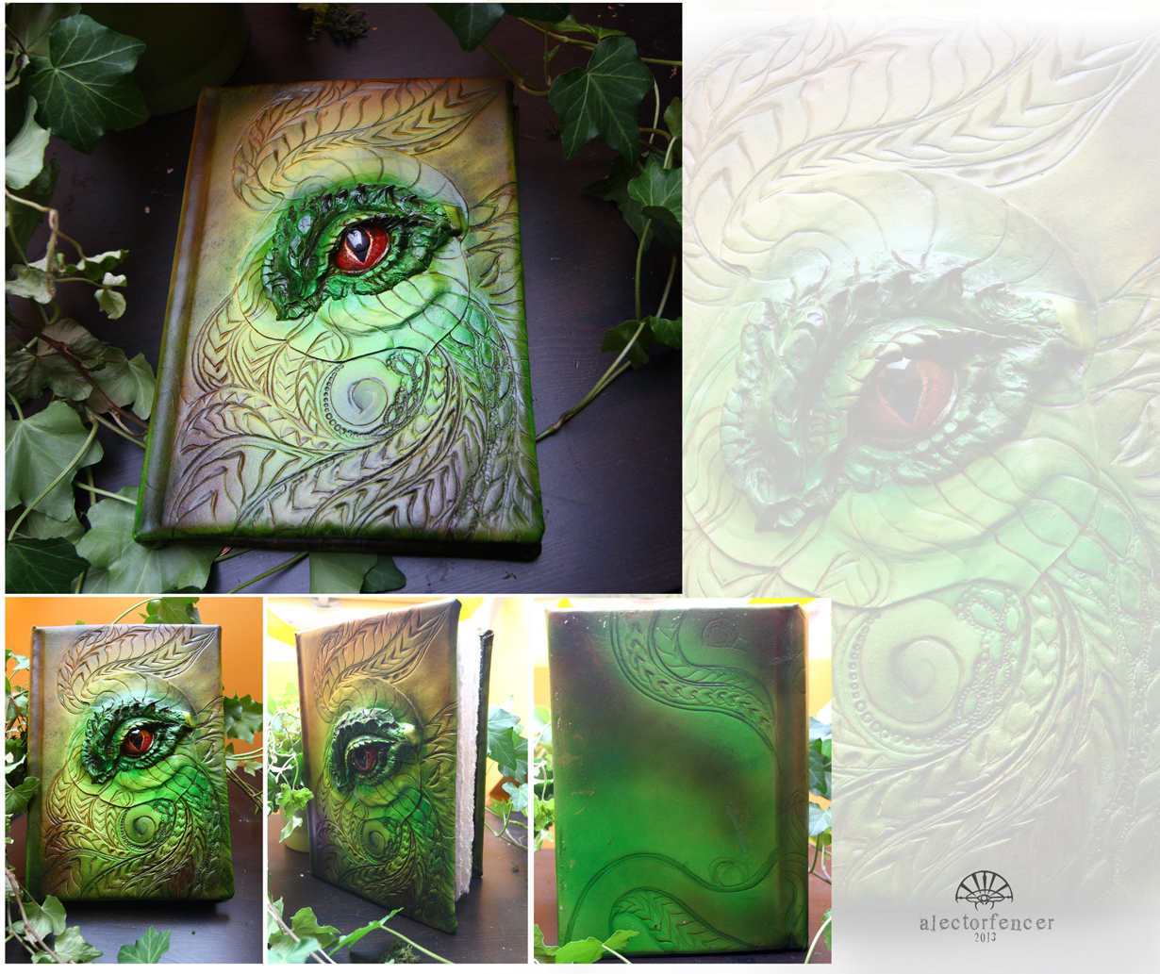

http://alectorfencer.deviantart.com/art/Dragon-Book-394634076